Optimizing Sales and Services of a Financial cum Service-Based Firm
A Proposal report for the BDM capstone Project

Submitted by
Name: Debjit Mondal
Roll number: 23f2004618
Email: 23f2004618@ds.study.iitm.ac.in



IITM BS Degree Program,
Indian Institute of Technology, Madras, Chennai
Tamil Nadu, India, 600036

Declaration Statement

I am working on a Project titled Optimizing Sales and Services of a Financial cum Service-Based Firm. I extend my appreciation to Unique Enterprise, for providing the necessary resources that enabled me to conduct my project.
I hereby assert that the data presented and assessed in this project report is genuine and precise to the utmost extent of my knowledge and capabilities. The data has been gathered from primary sources and carefully analyzed to assure its reliability.
Additionally, I affirm that all procedures employed for the purpose of data collection and analysis have been duly explained in this report. The outcomes and inferences derived from the data are an accurate depiction of the findings acquired through thorough analytical procedures.
I am dedicated to adhering to the principles of academic honesty and integrity, and I am receptive to any additional examination or validation of the data contained in this project report.
I understand that the execution of this project is intended for individual completion and is not to be undertaken collectively. I thus affirm that I am not engaged in any form of collaboration with other individuals, and that all the work undertaken has been solely conducted by me. In the event that plagiarism is detected in the report at any stage of the project's completion, I am fully aware and prepared to accept disciplinary measures imposed by the relevant authority.
I understand that all recommendations made in this project report are within the context of the academic project taken up towards course fulfillment in the BS Degree Program offered by IIT Madras. The institution does not endorse any of the claims or comments.

Signature of Candidate:

Name: Debjit Mondal

Contents
- Executive Summary 3
- Organizational Background 3
- Problem Statement
  - Problem Statement 1 4
  - Problem Statement 2 4
- Background of the Problem 4
- Problem Solving Approach 5
- Expected Timeline 7
- Expected Outcome 8

Executive Summary
Unique Enterprise is a financial and service-based firm established in 2019, with its primary focus on mutual fund sales. Over time, the business has expanded its service portfolio to include insurance products, financial services such as income tax return (ITR) filing and money transfers, as well as air and railway ticket booking. The firm caters to a diverse customer base, offering essential financial solutions with an emphasis on transparency, reliability, and customer satisfaction.
Despite its diverse offerings, Unique Enterprise faces a few challenges. The firm is struggling to maximize profit from mutual fund sales, as earnings in this segment have not grown as expected. Additionally, there are difficulties in aligning client portfolios with their individual risk profiles, leading to inconsistencies in investment strategies and affecting overall customer satisfaction. Although the business collects substantial data, it has not been fully utilized to assess key metrics like profitability, customer retention, and service demand.
To overcome these challenges, the project will focus on leveraging the existing data to improve decision-making processes. By implementing a structured approach to data analysis, the business will be able to identify high-performing funds and enhance operational efficiency. Additionally, aligning client portfolios more closely with their risk profiles will lead to better customer satisfaction and retention.With these improvements, Unique Enterprise will be better positioned to increase profit, better customer retention and achieve sustainable growth in the financial services sector.

Organizational Background
The firm selected for this project is Unique Enterprise, a B2C financial services firm established in 2019 by Mr. Indrajit Mondal. The business primarily focuses on mutual fund sales, which form the core of its operations. In addition to mutual funds, Unique Enterprise also offers a range of services including sales of various types of insurance, income tax return (ITR) filing, air and railway ticket booking, money transfer services, and bill payments.
The enterprise is solely operated by Mr. Indrajit Mondal, daily from 9:00 AM to 9:00 PM, ensuring extended service hours and consistent availability for its clients.
With a vision to strengthen its market presence, Unique Enterprise is committed to enhancing the customer experience, optimizing service delivery, and continually improving its financial service offerings.

Problem Statement
The business problem that has been identified after discussing with the owner are as follows:

Challenges in Maximizing Profit from Mutual Fund Sales: The business is currently facing challenges in maximizing profit from mutual fund sales. Despite existing efforts, earnings from this segment have not been growing as expected, and there is a need to identify and implement more effective strategies. The business is seeking to better understand the underlying factors limiting growth and explore opportunities to maximize profit from mutual fund sales.
  - Difficulties in Aligning Client Portfolios with Risk Profiles: The firm is facing challenges in aligning client portfolios with their individual risk profiles.

Background of the Problem

Challenges in Maximizing Profit from Mutual Fund Sales:
    - Internal problem: The commission structure of mutual funds is based on AUM (Asset under Management), where higher-return mutual funds generate more returns and, consequently, contribute to the growth of AUM. However, mutual fund sales are made on an ad-hoc basis rather than through a data-driven approach, which leads to missed opportunities for optimizing profit and aligning product offerings with client needs.
    - External problem: The performance of mutual funds is heavily influenced by market conditions, which introduces volatility and causes fluctuations in AUM. Moreover, during market downturns, investor confidence often declines, leading to reduced investment inflows and, in many cases, increased redemptions. This behavior exacerbates the instability of mutual fund performance and causes a decrease in AUM.

  - Difficulties in Aligning Client Portfolios with Risk Profiles:
    - Internal Problem: The business lacks a systematic method to assess clients' risk tolerance and financial needs when recommending mutual funds. Without this critical information, it's difficult to tailor investment strategies that align with individual client profiles, potentially leading to mismatched fund recommendations and lower client satisfaction.
    - External Problem: Clients often have a limited understanding of their own risk tolerance and financial goals, which makes it challenging for them to accurately communicate their needs. Moreover, competing digital platforms now offer personalized investment services, leveraging advanced algorithms and data analytics to provide tailored solutions, creating additional pressure on the business to adapt and enhance its client offerings.

Problem Solving Approach
To address the challenges Unique Enterprise is facing, a comprehensive, data-driven solution is essential. The business already has investment data, but it has not yet been fully utilized to its potential. A systematic approach to data collection, analysis, and actionable insights will be key in optimizing mutual fund sales, aligning client portfolios with their risk profiles, and improving operational efficiency. By implementing data-driven strategies, the firm can make decisions and improve service delivery leading to sustainable growth.
  - Methods to Address the Problem:
    - Comparative Analysis of Mutual Fund Returns: By using time series analysis of the historical performance of mutual funds, we can identify funds that have outperformed others. By recommending funds with a strong track record of performance, the firm can enhance client confidence and investment outcomes, which in turn increases the chance of new and repeated investment and also lower redemption rate which follows overall growth in Assets Under Management (AUM). As the AUM grows, it leads to higher commission-based profit for the firm.

    - Risk Tolerance Assessment: A fundamental aspect of aligning mutual fund investments with client needs is accurately assessing their risk tolerance. This involves collecting data on a client’s comfort level with risk through tailored questionnaires, which help determine their investment profile. By analyzing previous investment portfolios alongside self-reported risk preferences, clients can be categorized into conservative, moderate, or aggressive risk profiles. Their portfolios can then be adjusted accordingly to ensure better alignment with their financial goals and individual risk tolerance.

Intended Data Collection:
    - Mutual Fund transaction Records: The study will collect mutual fund transaction records from the past three years. This data will provide insights into the performance, volume, and trends within the mutual fund segment of the business, offering a statistical overview of client activity and business growth.
    - Mutual Fund Historical Data: The business receives regular updates on mutual fund performance from a partnering agency. This historical data will be used to categorize mutual funds based on their returns over different time periods, enabling more informed recommendations tailored to client risk profiles.
    - Risk Assessment Form: A risk assessment form will be distributed to clients via the owner. This form will include targeted questions related to financial goals, investment knowledge, and risk capacity. The responses will be used to categorize investors into risk profiles—conservative, moderate, or aggressive—supporting better alignment between client preferences and portfolio strategies.

Analysis Tools
    - Spreadsheet: For data entry, filtering, and summary statistics.
    - Numpy and Pandas: For data wrangling and exploratory data analysis.
    - Scikit Learn : For clustering and data analysis.
    - Matplotlib: For visualizing trends and clusters.

Expected Timeline

Task:
    - Business discussions: 20th and 21st April
    - Data collection: 26th April- 25th May
    - Data cleaning and structuring: 26th - 27th May
    - Data analysis : 28th May - 3rd June
    - Mid-term report preparation: 4th - 5th June
    - Mid-term report submission: 6th June
    - Refinement & further analysis: 6th - 15th June
    - Final submission report preparation: 16th-30th June
    - Final report submission: 1st July
    - Viva-voce: July

Gantt Chart
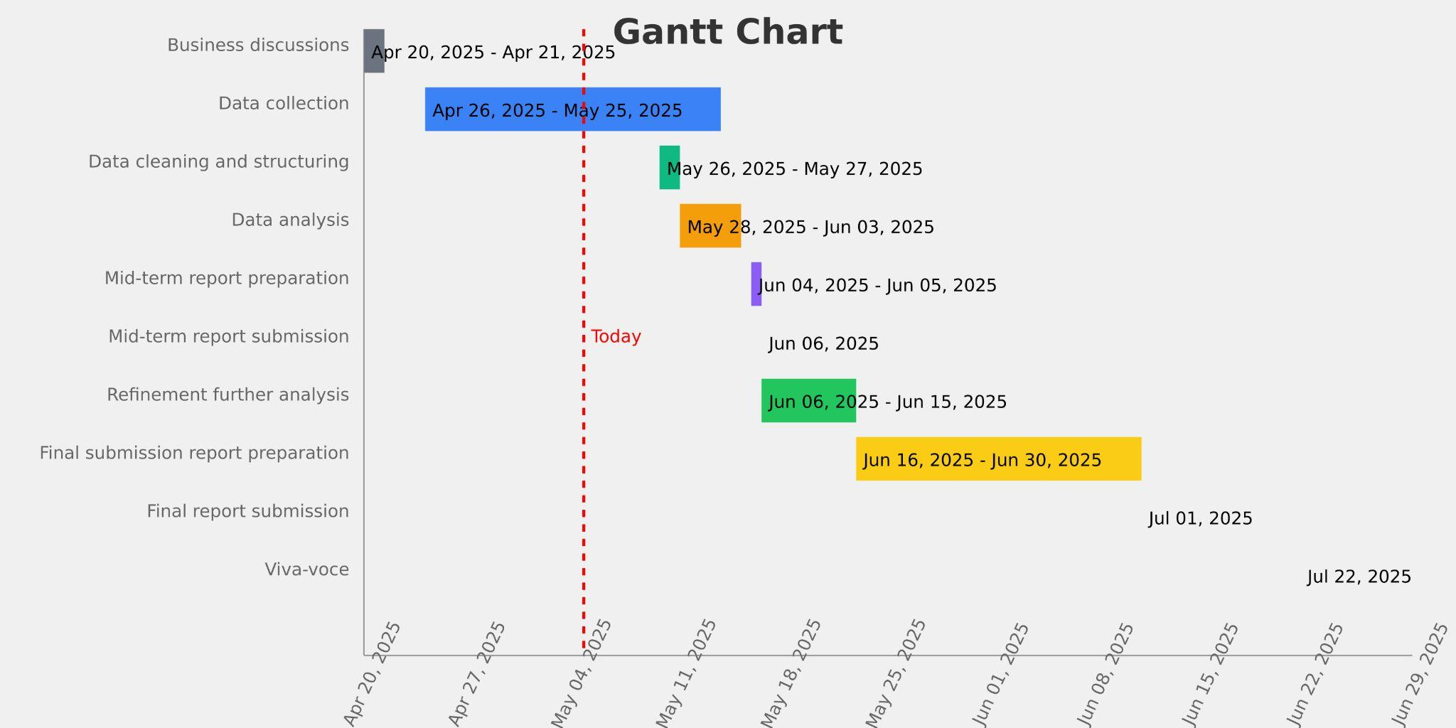

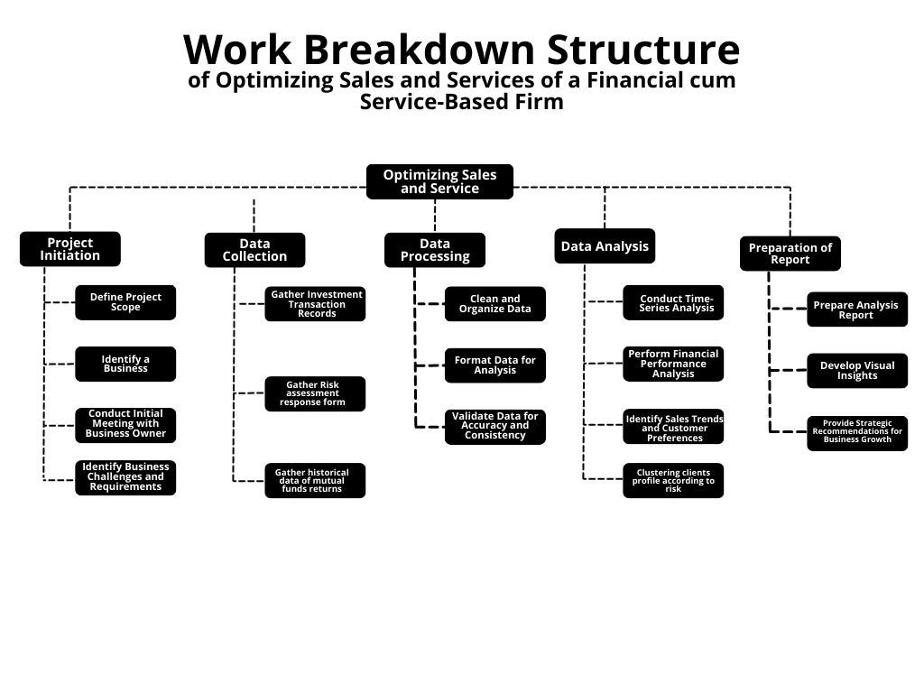
Work Breakdown Structure

Expected Outcome
The expected outcome of this study is to improve client retention, overall AUM and profitability by personalizing financial recommendations based on customer preferences and behavior of the mutual funds’ growth. By utilizing data analytics for time-series and performance analysis, the business can make informed decisions and identify growth opportunities. Tailored engagement will boost client satisfaction and loyalty, while analyzing high-performing investment products will enhance profit. These strategies will create a client-focused, data-driven approach that improves retention and increases profitability.

